Fatigue (and Problem-Solving) Journal

Circles of Social Support
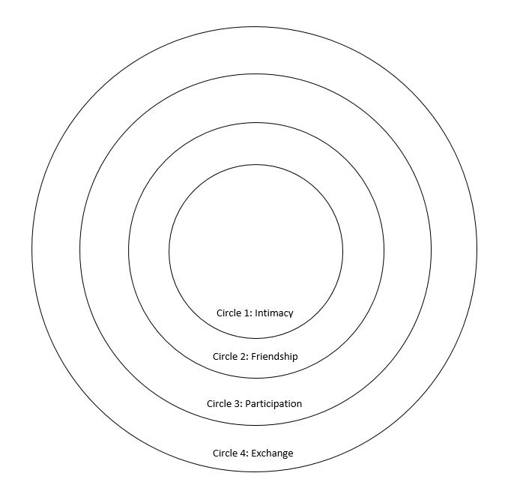

Falvey, M. A., Forest, M., Pearpoint, J., & Rosenberg, R. L. (Eds.). (2003). All my life’s a circle. Toronto: Inclusion Press.
My Roles

My Identity Pie Chart

How did I come to be where I am? What made me someone who serves and helps care for others?

How has my personal and/or work life changed me?

What makes the difference between a good day and a bad one?

What kind of days leave me feeling satisfied and with a sense of accomplishment?

What are my core values?

What do I believe in?

What kind of life do I need to be living in order to have a sense of integrity?
Am I overstimulated? Do I do any of the following?
- Send work-/care-related texts or emails while driving?
- Sleep with my cell phone close enough that it will wake me in the night?
- Work in the bathroom? Work while in bed?
- Interrupt conversations to check emails and texts?
- Allow my work phone to interrupt your meals?
- Work at the gym?
- Answer the phone when I was asleep?
- Choose to work from home instead of taking a sick day?
- Hesitate to take vacation time for fear of missing something?
- Work when I have the day off? Turn down opportunities to have time to myself?
- Have trouble paying attention during meetings because I’m worried about my phone?
What is one thing I can change about my phone use to reduce stress in my life?

What is rewarding about my job/life? What are the best parts?

What is challenging about my job/life? What are the hardest parts?

How can I tell when I’m starting to get burned out or emotionally drained?

How is the culture of my office/household affecting me?

Are there certain people with whom I always tend to become more negative?

What can I do to make my contribution to the office/household climate more positive?

What helps me feel better when I’m burning out? What works for me?

What are some of my most meaningful “victories”?

What are the sensations that I find calming?
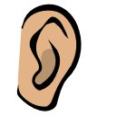
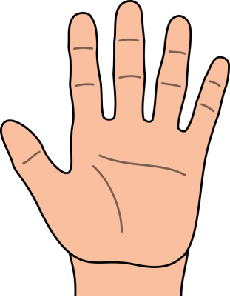
What things can I control about my job?
Can Control Cannot Control

What small change can I make in my lifestyle to increase well-being and reduce stress?

What is one promise I can make to myself?

What is one change I could make in my home or workplace when I am there TODAY?

One important thing I learned today was:
